**Name: Đinh Gia Bảo**

**Student ID: SE183741**

**LAB 2: USING BASIC   
 LINUX COMMANDS**

**Submission :**

*Upload the word file to cms describes some requirements:*

• Present the content of manipulating of some commands **(including syntax, what does it for?, examples)** as

* su
* env
* mkdir, cp, mv, rmdir, ln, cat, rm
* chown, chgrp, chmod
* find
* ds, df
* ps, top, kill, jobs

• Capture the terminal screen using the **“ls –al”** to view all the files that are done at tutorial in File manage.

Initially, use command ‘**sudo -i** ’ and enter your **password** to access the **root-user.**

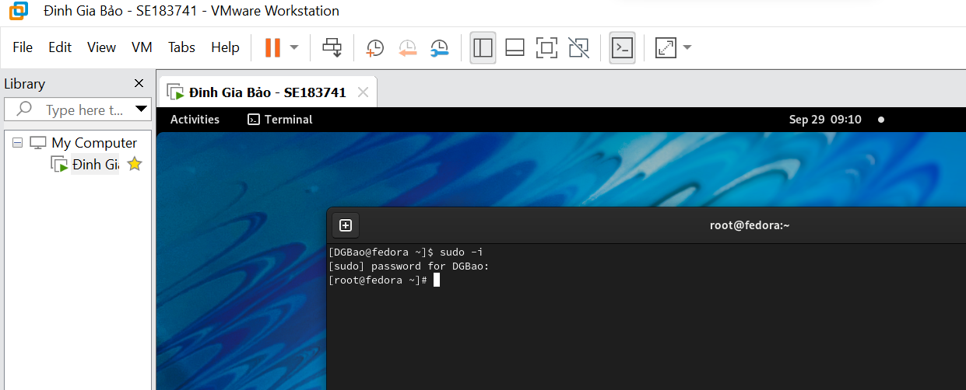

**su : ( Subtitute user identity )**

Run a command with substitute user and group id, allow one user to temporarily become another user. It runs a command (often an interactive shell) with the real and effective user id, group id, and supplemental groups of a given *user*.

Syntax

su [*options*]... [*user* [*arg*]...]

**Ex 1: $ su --version**

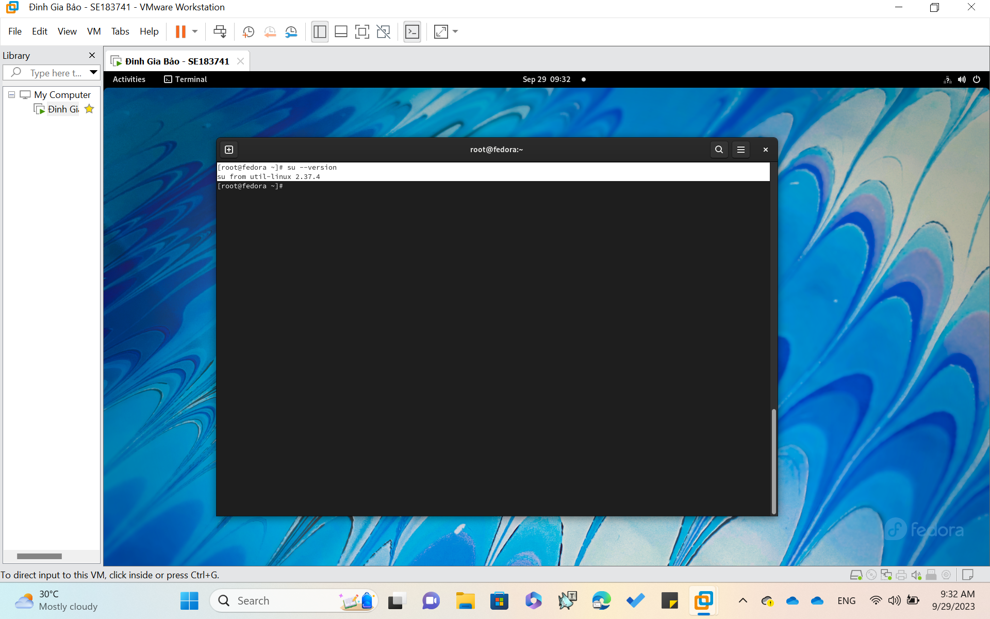

Output information version and exit

**Ex 2: $ su --help**

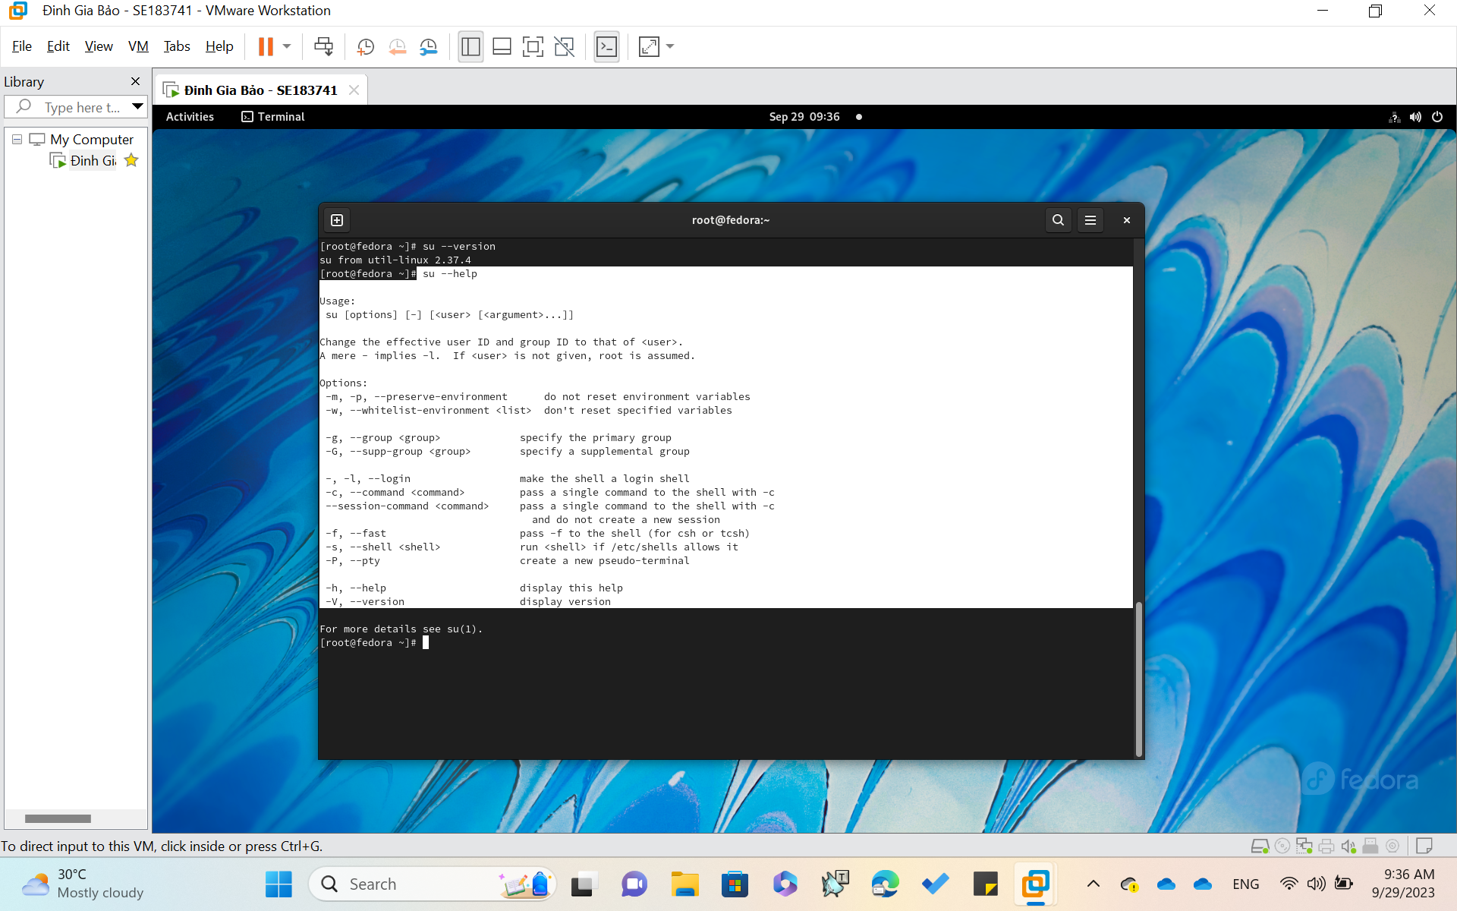

Display this help and exit

**env : ( Environmental variable )**

Display, set, or remove environment variables, Run a command in a modified environment.

Syntax

env [*OPTION*]... [NAME=*VALUE*]... [*COMMAND* [*ARGS*]...]

**Ex 1: $ env --unset=*NAME***

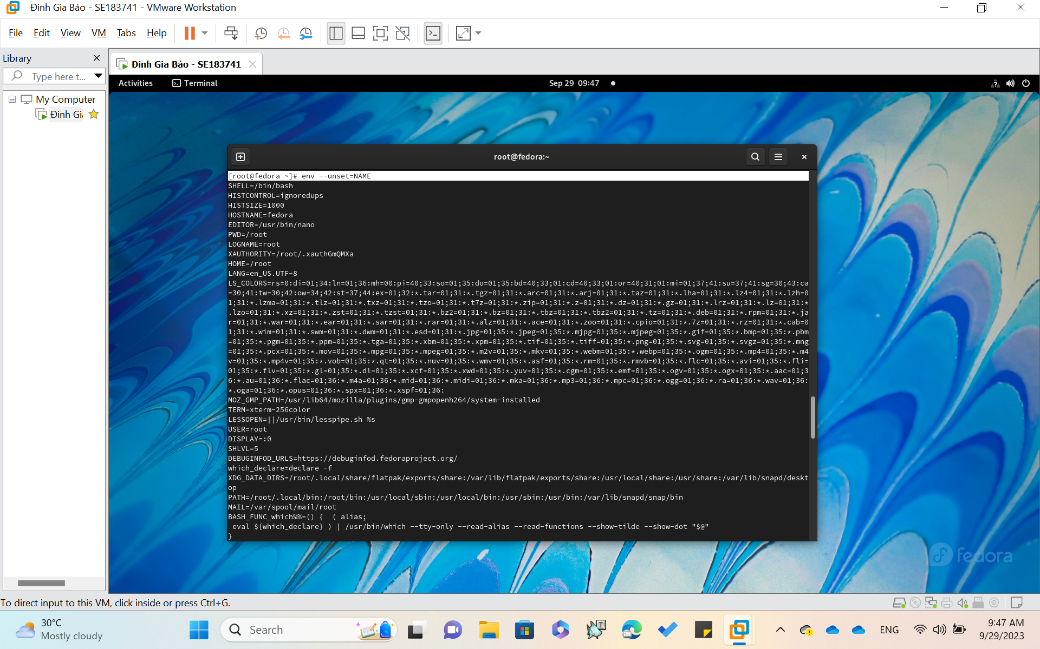

Remove variable *NAME* from the environment, if it was in the environment.

**Ex 2: $ env --ignore-environment**

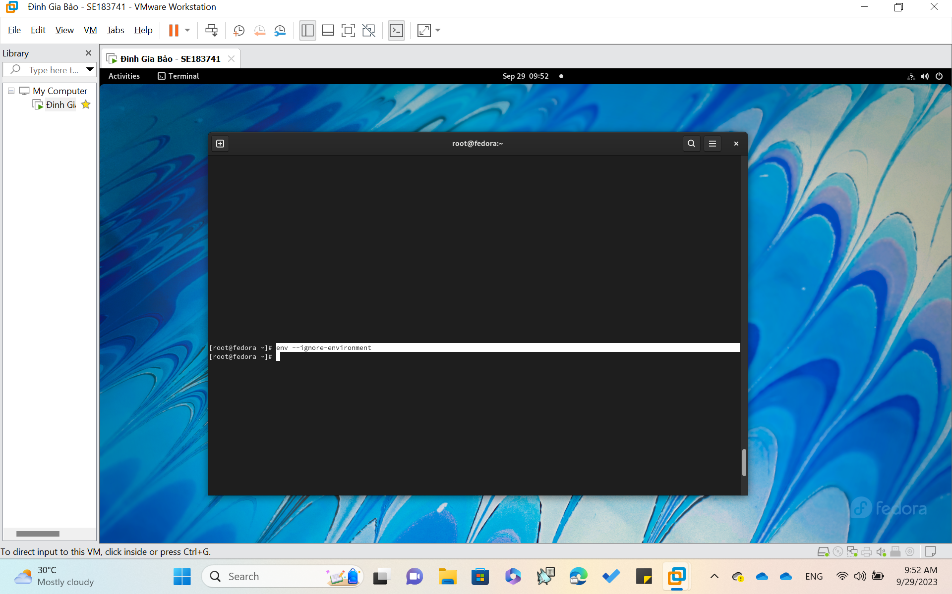

Start with an empty environment, ignoring the inherited environment.

**mkdir : ( Create new directory )**

Create new folder(s), if they do not already exist.

Syntax

mkdir [*Options*] *folder*...

mkdir "*Name with spaces*"

**Ex :** $ mkdir -p demo

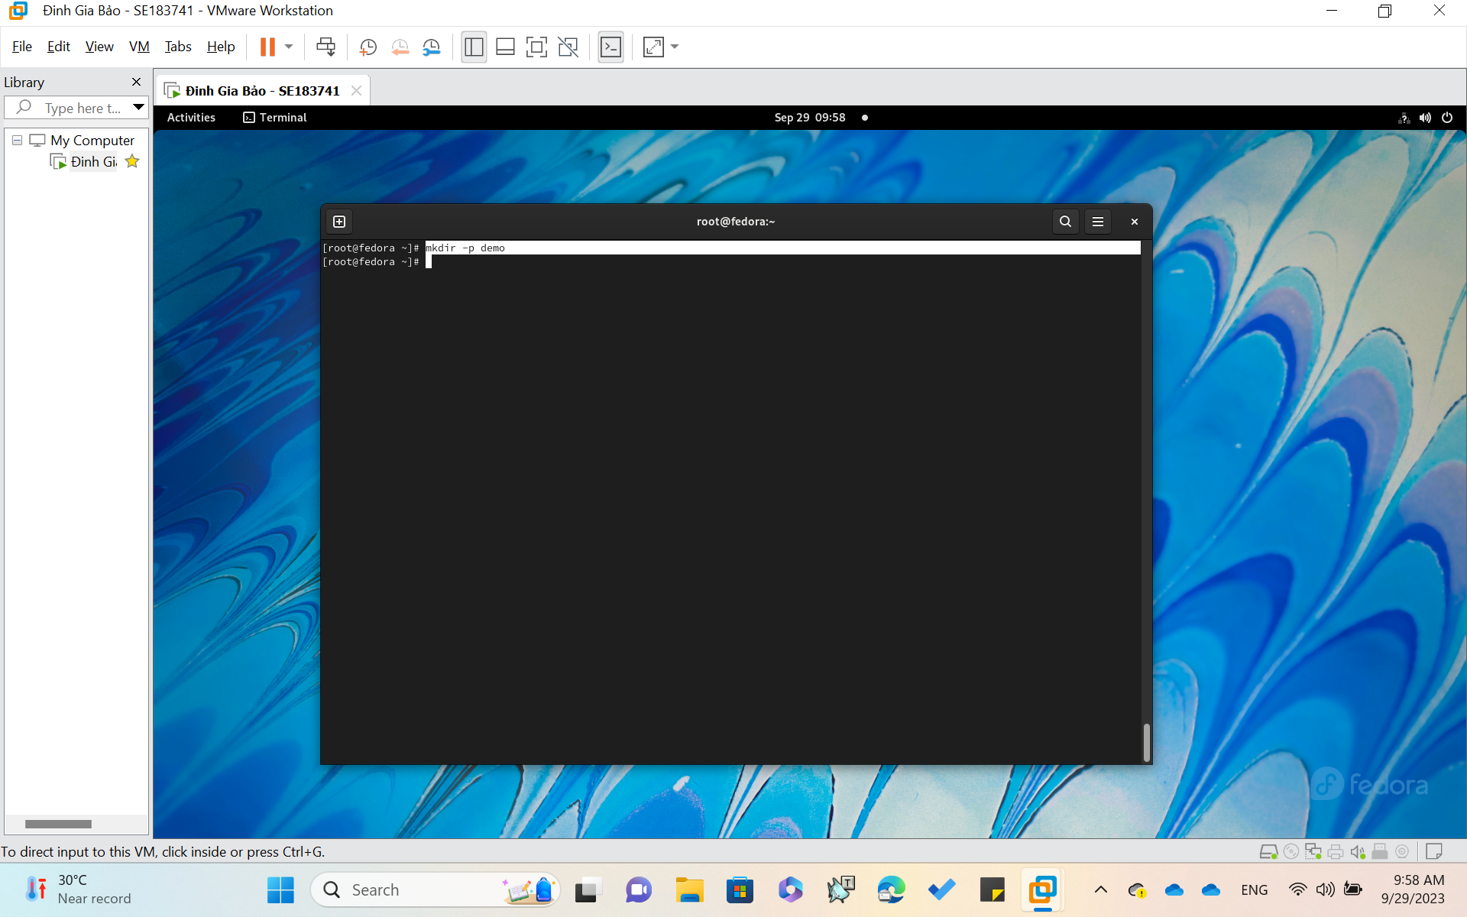

Create the folder 'demo'

**cp : ( Copy one or more files to another location )**

Copy SOURCE to DEST, or multiple SOURCE(s) to DIRECTORY.

Syntax

cp [*options*]... *Source* *Dest*

cp [*options*]... *Source*... *Directory*

**Ex: $ cp text2.txt text1.txt**

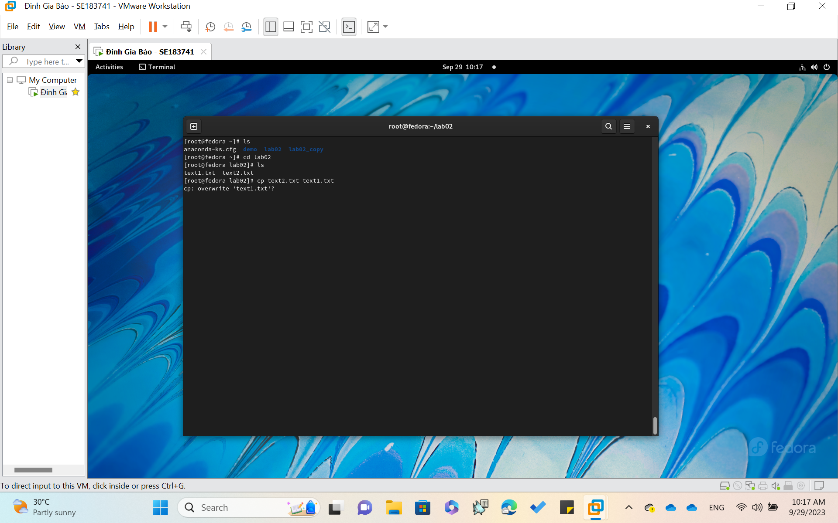

Copy text2 to text1

**mv : ( Move or rename files or directories )**

If the last argument names an existing directory, 'mv' moves each other given file into a file with the same name in that directory. Otherwise, if only two files are given, it renames the first as the second. It is an error if the last argument is not a directory and more than two files are given.

SYNTAX

mv [*options*]... *Source* *Dest*

mv [*options*]... *Source*... *Directory*

**Ex :**

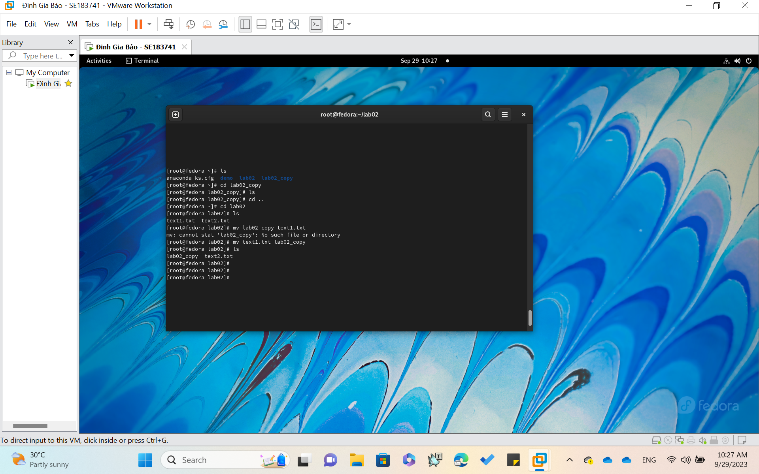

**rmdir : ( remove folders/directories )**

Remove directory, this command will only work if the folders are empty.

Syntax

rmdir [*options*]... *folder(s)*...

**Ex :**

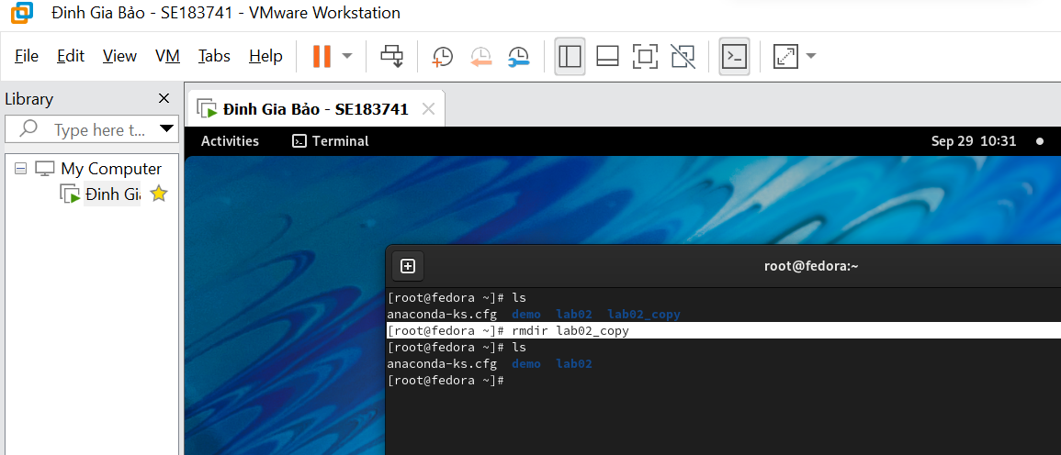

Remove lab02_copy directory

**ln : ( create a symbolic link to a file )**

Make links between files, by default, it makes hard links; with the -s option, it makes symbolic (or "soft") links.

Syntax

ln [OPTION]... [-T] *OriginalSourceFile NewLinkFile* (1st form)

ln [OPTION]... *OriginalSourceFile*  (2nd form)

ln [OPTION]... *OriginalSourceFile*... *DIRECTORY* (3rd form)

ln [OPTION]... -t *DIRECTORY OriginalSourceFile*... (4th form)

**Ex :**

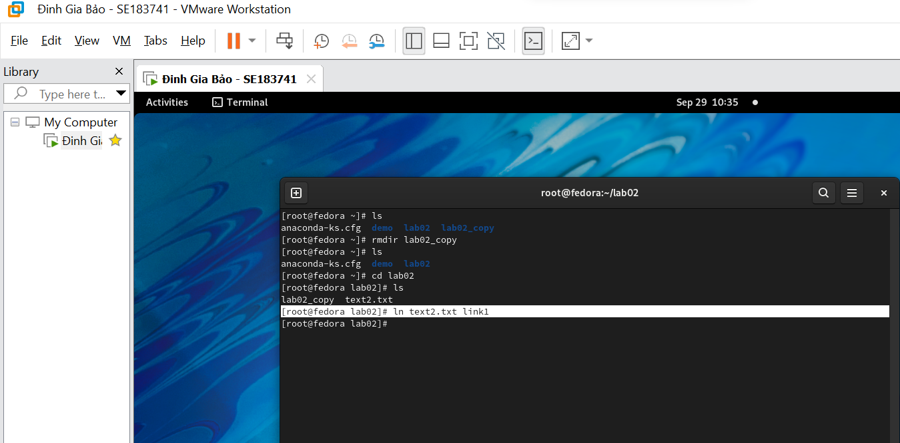

Create a symbolic link1 for file text2.txt

**cat : ( Concatenate and print/display the content of files )**

Concatenate *FILE*(s), or standard input, to standard output.

Syntax

cat [*Options*] [*File*]...

* First I will Create the file with name **trycat.txt** with content “**This is an example.**” located at 98 directory

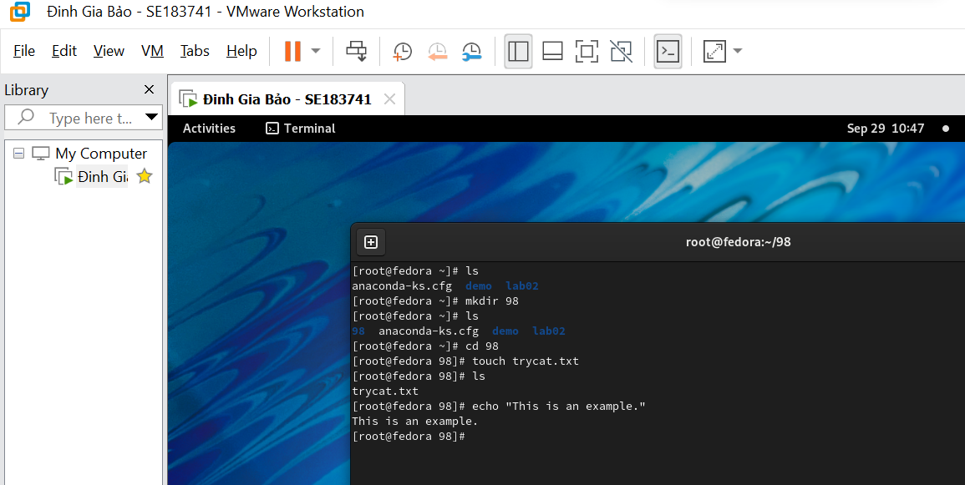

Use $ cat trycat.txt – to display content in file trycat.txt

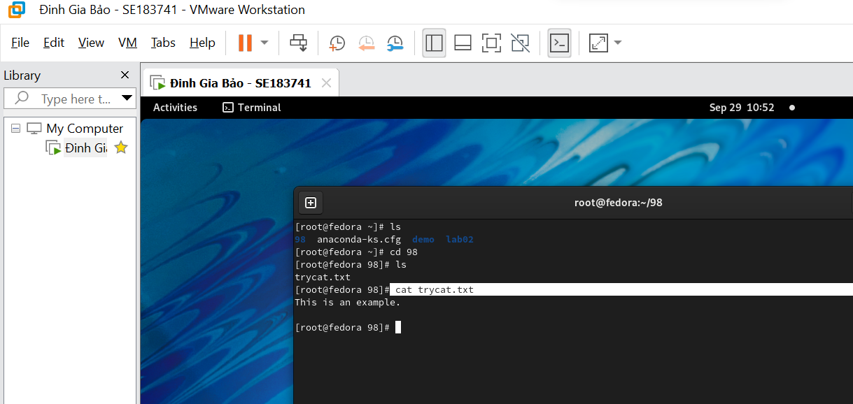

Display content ‘This is an example.’

**rm : ( remove file )**

Remove files (delete/unlink).

Syntax

rm [*options*]... *file*...

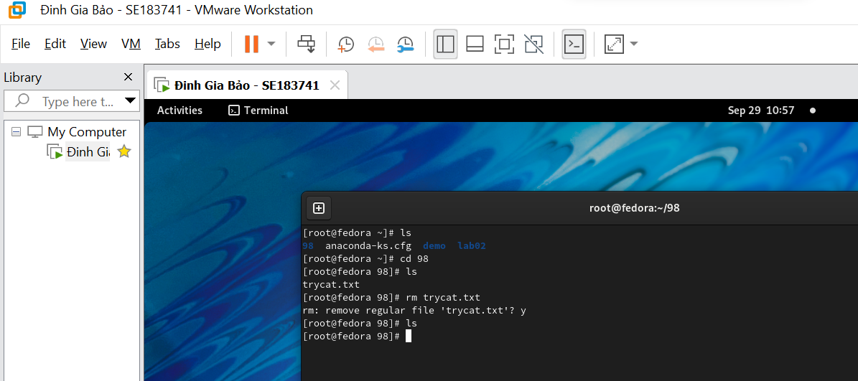

Remove file trycat.txt in 98 directory

**Chown : ( Change file owner and group )**

Change owner, change the user and/or group ownership of each given File to a new Owner.  
Chown can also change the ownership of a file to match the user/group of an existing reference file.

SYNTAX

chown [*Options*]... *NewOwner File*...

chown [*Options*]... :Group *File*...

chown [*Options*]... --reference=RFILE *File*...

**Ex :**

$ sudo chown DGBao MyText.txt

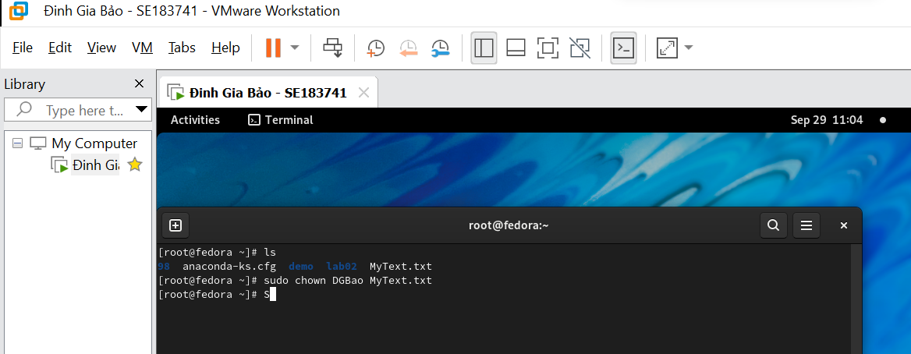

Assign DGBao as the owner of "MyText.txt" file in the root directory.

**chgrp : ( Change group ownership )**

'chgrp' changes the group ownership of each given *File* to *Group* (which can be either a group name or a numeric group id) or to match the same group as an existing reference file.

Syntax

chgrp [*Options*]... {*Group* | --reference=*File*} *File*...

Ex :

$ chgrp DGBao MyText.txt

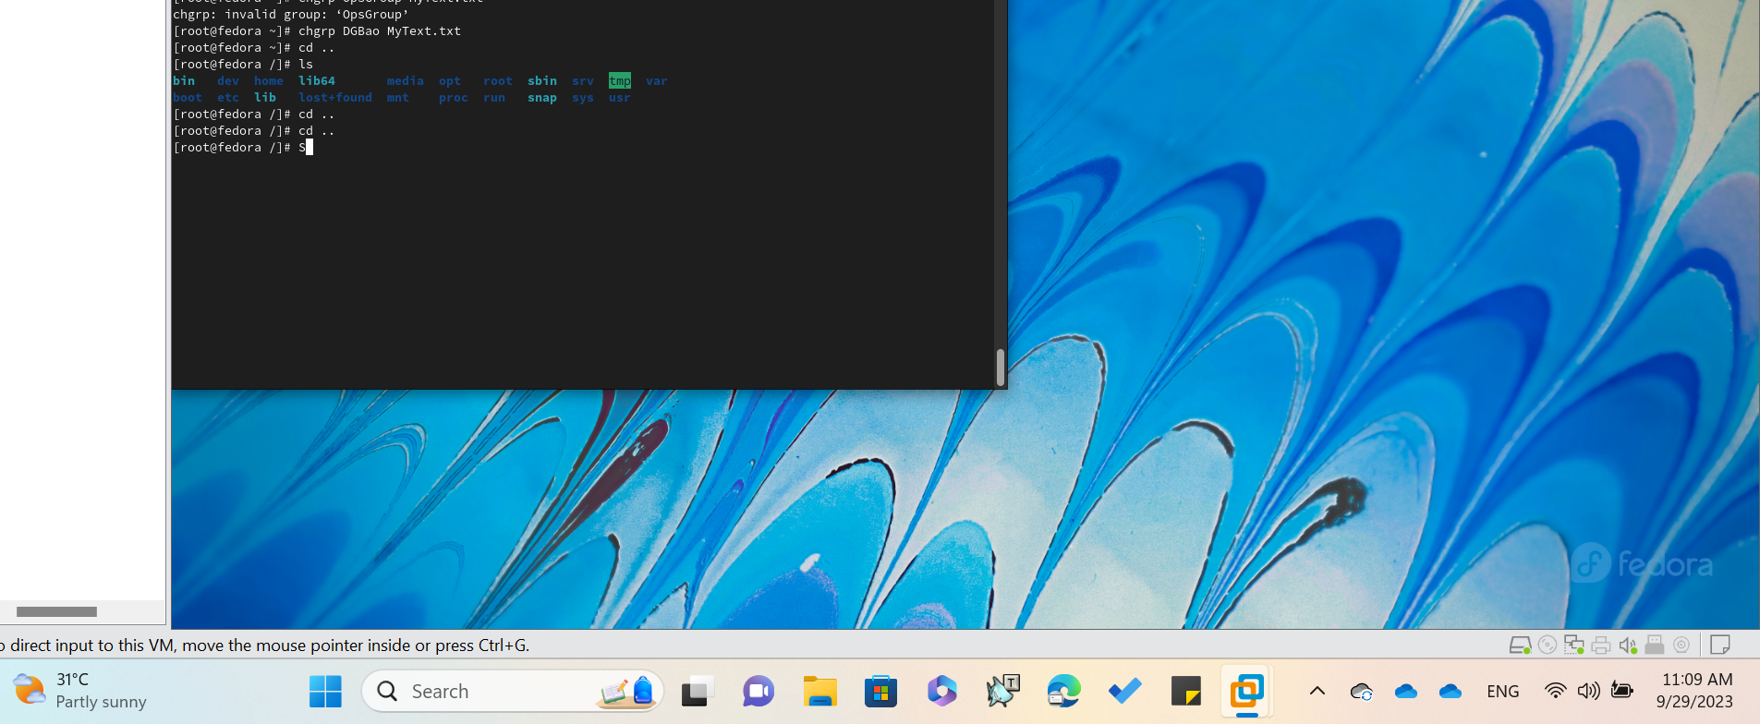

Change the group ownership of a file to 'DGBao'

**Chmod : ( Change access permission )**

Change access permissions, **ch**ange **mod**e.

Syntax

chmod [*Options*]... *Mode* [,*Mode*]... *file*...

chmod [*Options*]... *Numeric_Mode file*...

chmod [*Options*]... --reference=*RFile* *file*...

**Ex :** $ chmod -R a+rwx lab02/

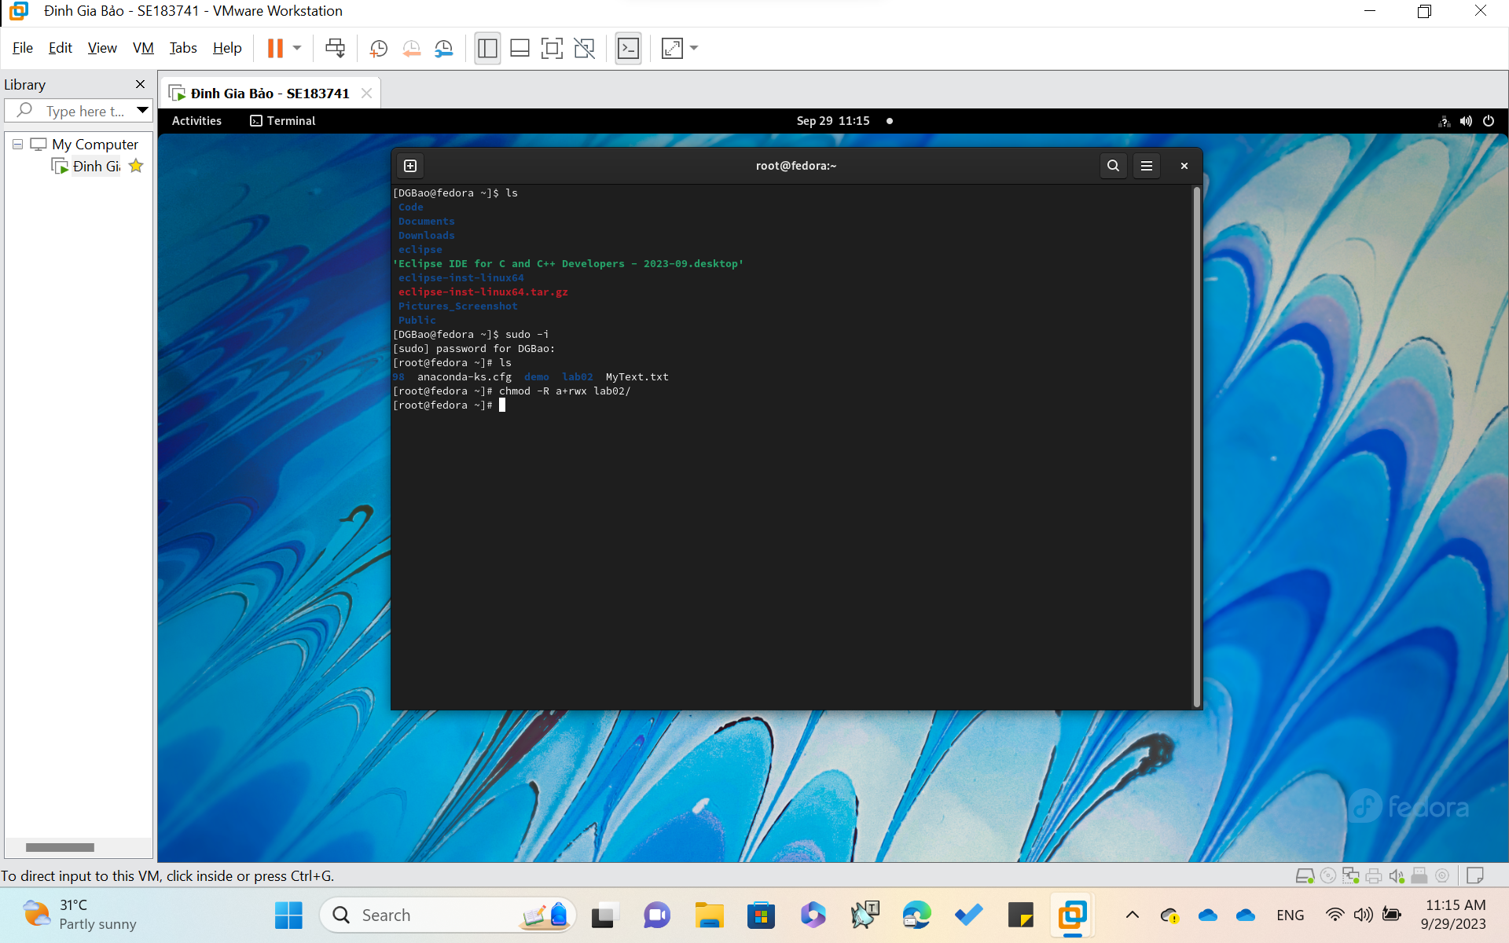

To grant read, write , and execute permission to everyone for a directory and all its files and subdirectories within the “lab02”directory

**find: ( search for files that meet a desired criteria )**

Search a folder hierarchy for filename(s) that meet a desired criteria: Name, Size, File Type - see [examples](https://ss64.com/bash/find.html#examples).

Syntax

find [-H] [-L] [-P] [*path*...] [*expression*]

GNU find searches the directory tree rooted at each given file name by evaluating the given *expression* from left to right, according to the rules of precedence ([see Operators](https://ss64.com/bash/find.html#operators)), until the outcome is known (the left hand side is false for **AND** operations, true for **OR**), at which point find moves on to the next file name.

Ex: $ find / -name "text2.txt”

Find all files with the name “text2.txt” throughout the entire system

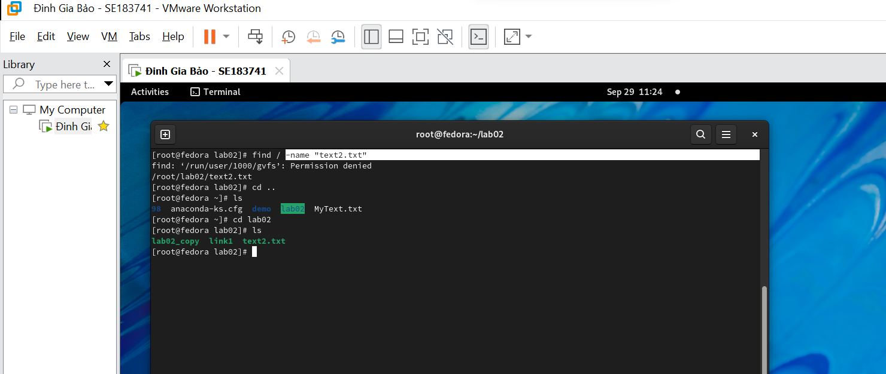

Find all files with the name “text2.txt” throughout the entire system

**df : ( Disk-Free)**

The df command in Linux and Unix-like operating systems is used to display information about disk space utilization on file systems. Its purpose is to provide a summary of the disk space usage, including details about total disk space, used space, available space, and the percentage of space used on each mounted file system. Here is the basic syntax of the df command:

Syntax : df [options] [filesystem...]

Ex : $ df -h

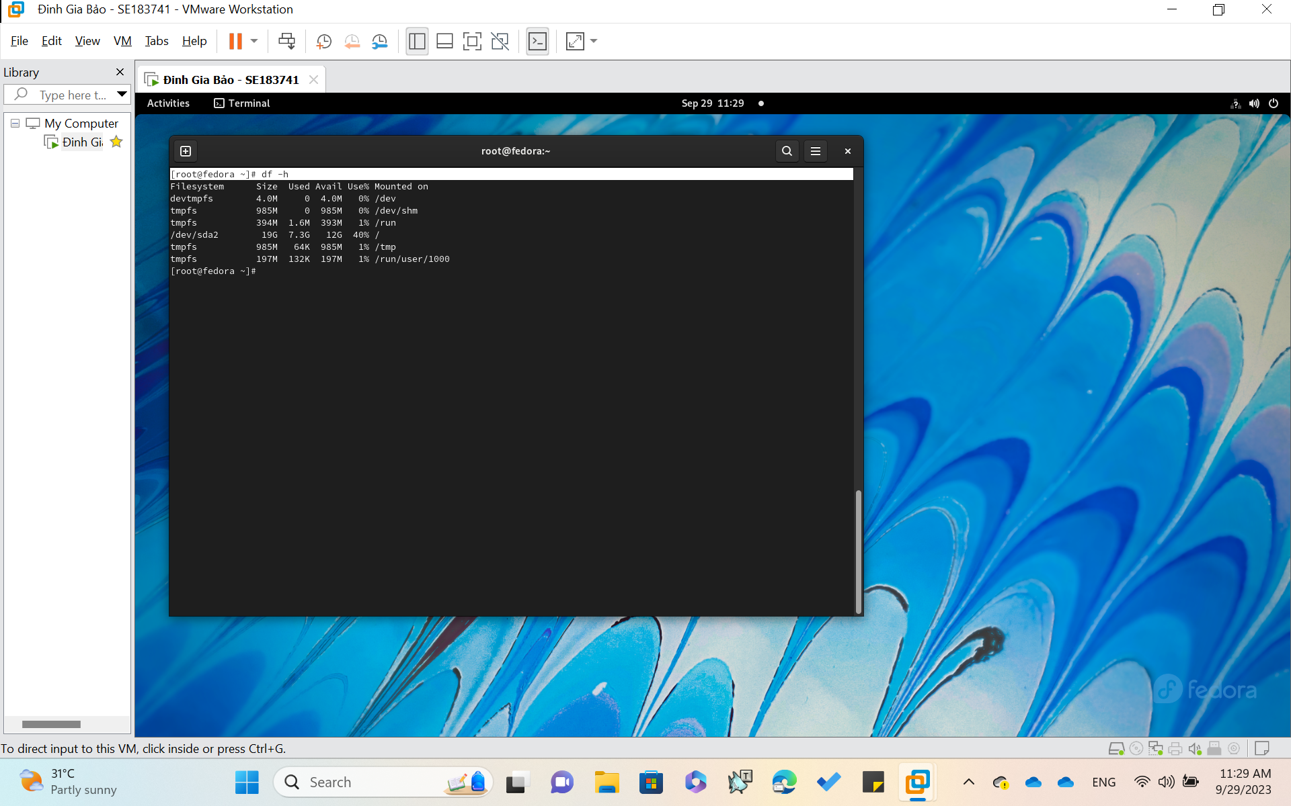

This command is used to display information about disk space and free space on the files systems mounted on your system.

**Ps: ( process status )**

Process status, information about processes running in memory. If you want a repetitive update of this status, use [top](https://ss64.com/bash/top.html).

Syntax

ps *option(s)*

Ex : $ ps -a

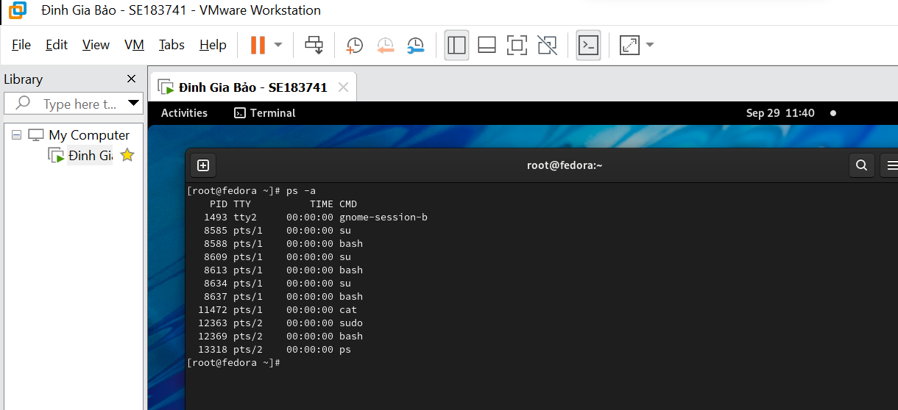

Select all processes except both session leaders (see getsid(2)) and processes not associated with a terminal.

**Top : ( List processes running on the system )**

Process viewer, find the CPU-intensive programs currently running. See [ps](https://ss64.com/bash/ps.html) for explanations of the field descriptors.

Syntax

top *options*

Ex : $ top -b

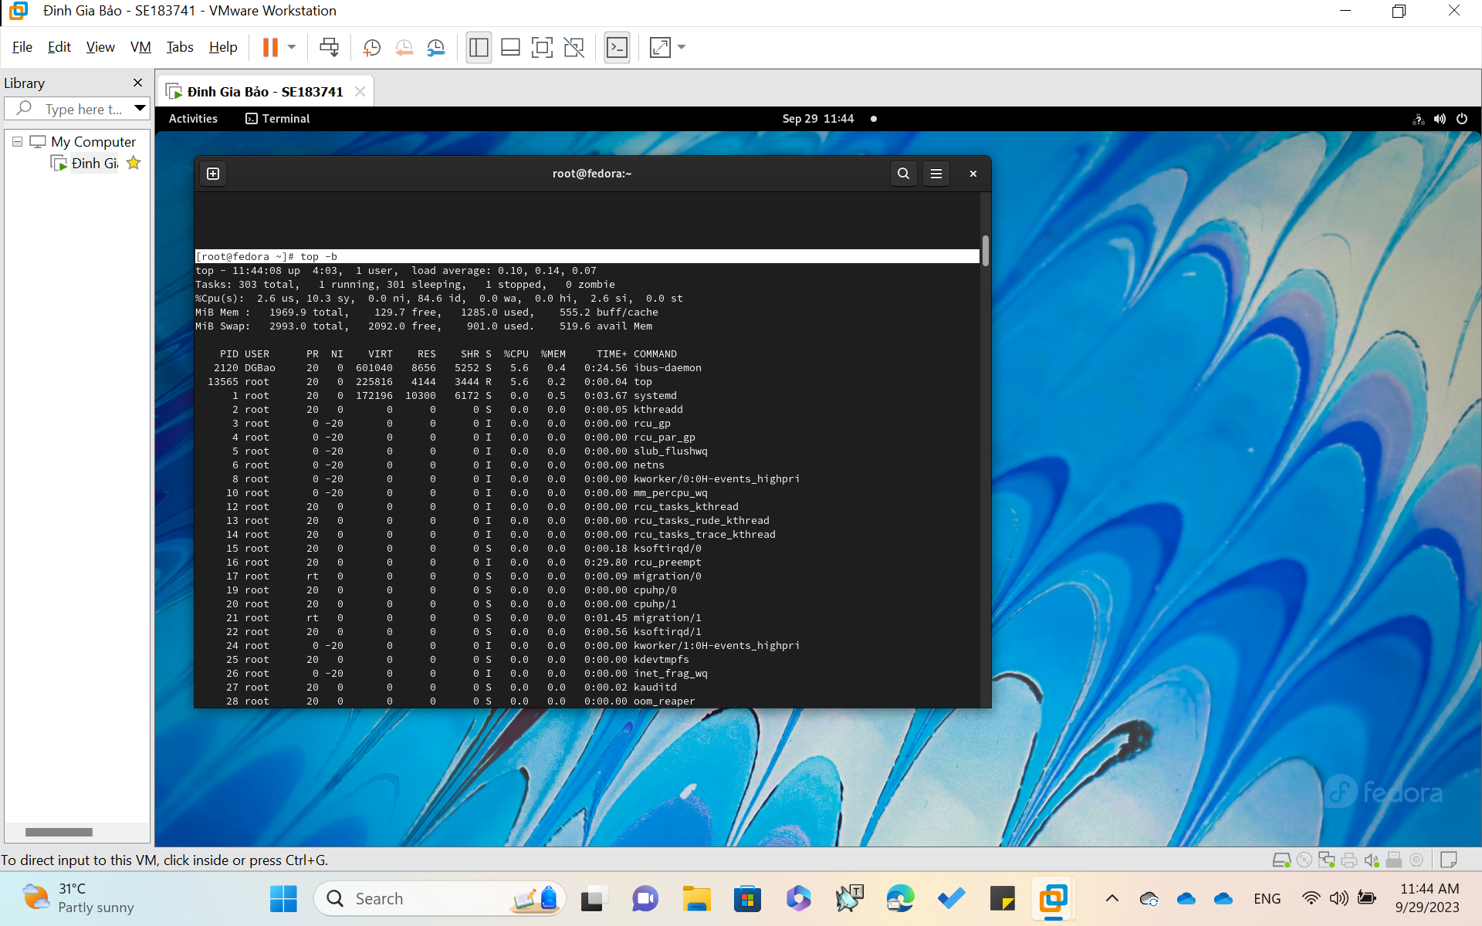

Run in batch mode; don't accept command-line input.

Useful for sending output to another command or to a file.

**Kill: ( Kill a process by specifying its PID )**

Kill a process by specifying its PID, either via a signal or forced termination.

Syntax

kill [-s *sigspec*] [-n *signum*] [-*sigspec*] *jobspec* or *pid*

kill -l [*exit_status*]

kill -l [*sigspec*]

**Ex : $ kill -l**

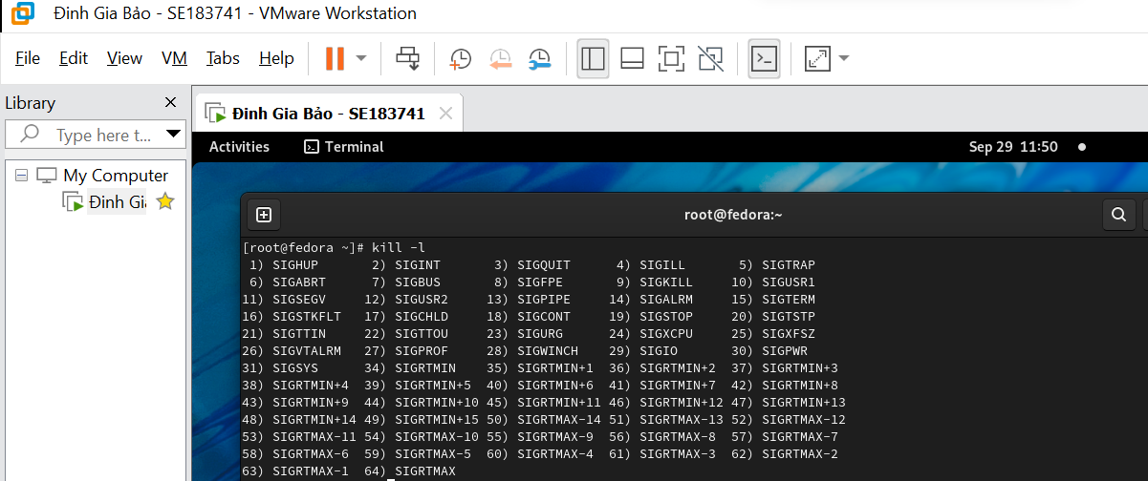

List the signal names

Jobs: ( list active jobs )

Print currently running jobs and their status.

Syntax

jobs [*OPTIONS*] [*PID*]

**Ex1 : $ jobs -l**

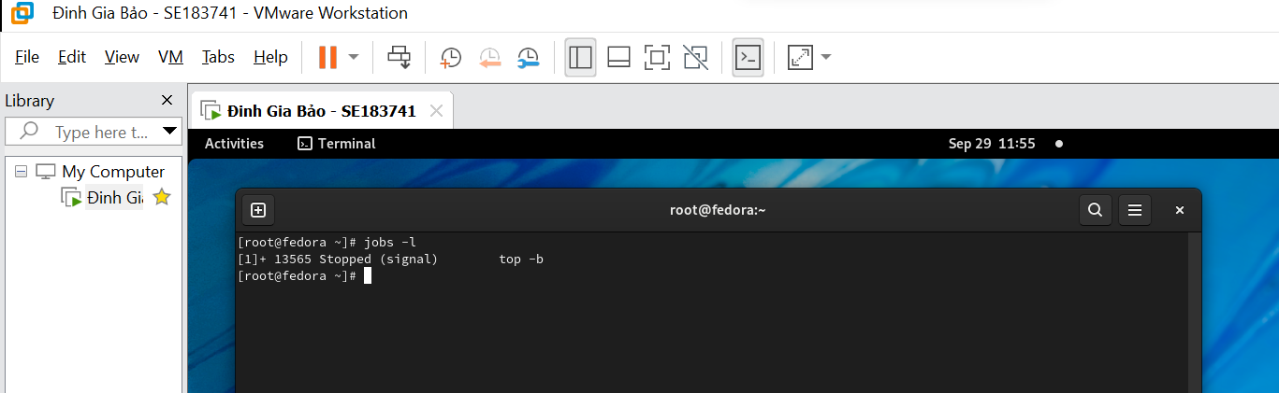

Only the last job to be started is printed

**Ex2 : $ jobs -p**

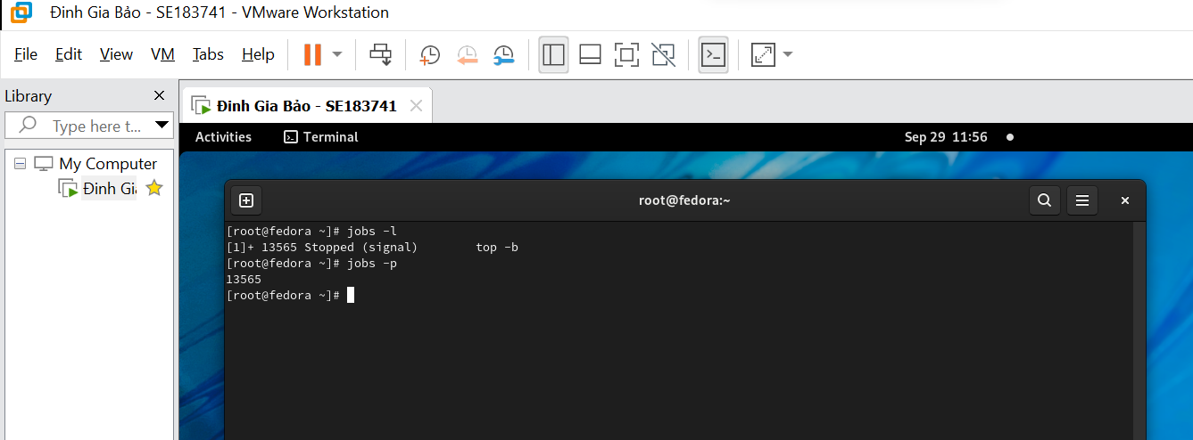

Print the process id for each process in all jobs

**ls -al :**

when you run ls -al, it will display a detailed list of all files and directories in the current directory, including hidden files, in a long format that shows additional information about each file and directory.

**Syntax: ls -al [directory]**

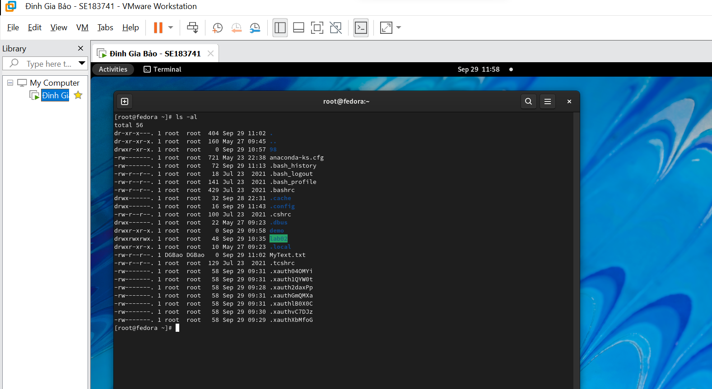

**END.**